rings/mounts/bases

34mm Tactical 6-Hole Picatinny Rings
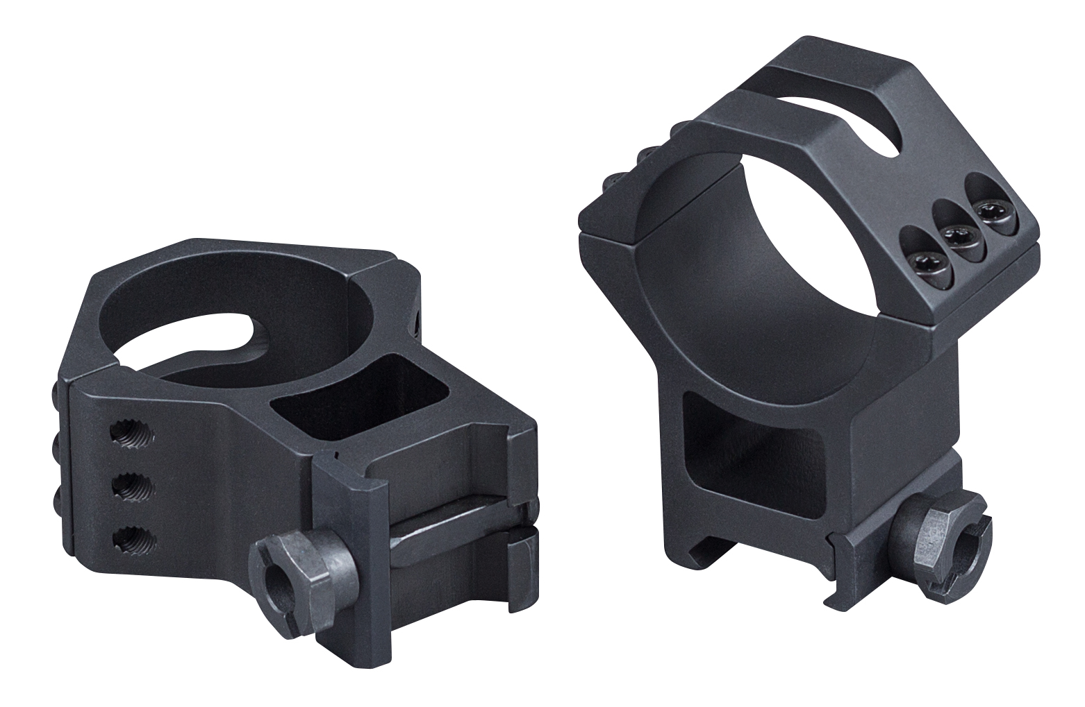
Heavy-duty doesn’t have to mean heavyweight. With a skeleton design, Weaver’s new 34mm 6-Hole Tactical Rings are lightweight and incredibly rugged. These rings feature six screws for maximum security and clamping pressure and an improved Picatinny crossbolt design that takes the classic Weaver® Crossbolt to Picatinny spec. The 7075-T6 aircraft-grade aluminum rings feature a Type-3 hard coat anodized finish, no strip/slip Torx screws and three height options to cover almost any tactical precision shooting system.

Features & Benefits
- Improved crossbolt from Weaver® to Picatinny spec
- Six screws for extra security and clamping pressure
- Made out of 7075-T6 aircraft-grade aluminum
- Type-3 hard coat anodized finish
- Made to exact tolerances in the U.S.A.

Part No. Description UPC MSRP
99682 34mm Tactical 6-Hole Rings- Low 0-76683-99682-4 $119.99
99684 34mm Tactical 6-Hole Rings- High 0-76683-99684-8 $119.99
99686 34mm Tactical 6-Hole Rings- XX-High 0-76683-99686-2 $119.99

